Ancient Mersin VR at EMITT

UX Case Study – Field Research

Role: UX Researcher & Interaction Designer
Context: Public expo booth, VR cultural heritage experience

What is the experience?
Visitors explore the ancient history of Mersin through an immersive Virtual Reality journey. They interact with historical characters and environments, experiencing daily life and cultural narratives from antiquity in a first-person perspective.

Who is it for?
The experience is designed for a broad audience, including tourists, industry professionals, students, and first-time VR users. It is accessible to people with different levels of technological familiarity.

Why does it matter?
Mersin has a rich yet underrepresented cultural and historical heritage. This project aims to transform this latent potential into an engaging digital experience, increasing awareness among visitors who may have little prior knowledge of the city’s past.

What do I want users to feel?
I want visitors to feel excitement, curiosity, and emotional connection. Ideally, they should leave the experience feeling inspired, impressed, and motivated to learn more about Mersin’s cultural heritage.

Problem Statement
Mersin has a rich cultural and historical heritage, but for many visitors, this heritage remains distant, abstract, and difficult to experience in an engaging way. Traditional exhibitions and static displays often fail to create emotional connection and long-term interest.
This project addresses the challenge of transforming cultural information into an immersive, accessible, and memorable experience through Virtual Reality.

My Contribution and Design Goal
My goal was to support the creation of an immersive and accessible cultural experience by observing user behavior, reducing friction during onboarding, and collecting meaningful feedback for future improvements.

User Flow & Interaction Design

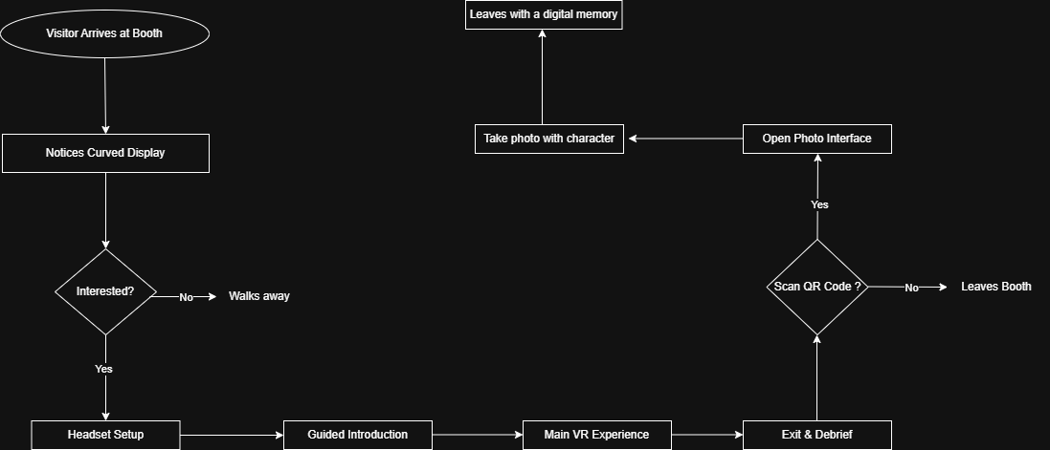

The user journey begins when a visitor arrives at the exhibition booth and notices the curved display presenting visual previews of the VR experience. This initial exposure functions as an attractor, encouraging passersby to pause and evaluate their interest.
At this stage, visitors make a quick decision: if the content does not capture their attention, they continue walking. If they are interested, they approach the booth and engage with the staff.
After expressing interest, visitors are guided through the headset setup process and receive a short verbal and visual introduction explaining what to expect. This onboarding phase is designed to reduce uncertainty and ensure physical comfort.
Once prepared, users enter the main VR experience, where they explore reconstructed ancient environments and interact with historical characters. This phase represents the core immersive component of the journey.
After completing the session, visitors exit the experience and participate in a brief debriefing, during which they are informed about additional digital features and invited to share feedback.
At this point, users may choose to scan a QR code to access the extended experience. Those who scan the code are directed to a mobile photo interface, where they can take a personalized photo with a historical character.
Finally, users download or share their image and leave the booth with a digital memory of the experience. Visitors who choose not to scan the QR code exit the booth directly after the debriefing stage.

Journey Map

The journey map illustrates how visitors interact with the Ancient Mersin VR installation from initial discovery to post-experience engagement. The experience begins with a brief attention window in a crowded exhibition context, where strong visual cues are essential to attract interest.
As visitors approach the booth, hesitation is primarily driven by uncertainty about the technology and potential discomfort. Clear verbal guidance and visible demonstrations play a critical role in reducing this barrier and encouraging participation.
During the immersive phase, emotional engagement increases significantly, especially when users encounter recognizable historical environments and characters. However, usability clarity and onboarding remain essential to sustain attention and prevent confusion.
The post-experience stages extend the interaction beyond the physical installation through the QR-based photo feature. This extension transforms a temporary experience into a memorable digital artifact, supporting long-term recall and social sharing.
Overall, the journey highlights the importance of combining clear onboarding, emotionally engaging content, and post-experience interaction to create a cohesive and memorable cultural heritage experience.

STAGE | USER ACTION | USER EMOTION | PAIN POINTS | Opportunities / Design Response
Discover | Notices the curved display while walking through the exhibition. | Curious | May ignore or pass by quickly. | Use strong visuals and a clear narrative preview to capture attention within seconds.
Approach | Moves closer to the booth and observes others. | Interested but cautious | Uncertainty about what the experience is. | Provide a short, friendly invitation and visible demonstration.
Decision | Decides whether to try the VR experience. | Hesitant | Fear of discomfort or unfamiliar technology. | Offer reassurance and explain the duration and safety.
Onboarding | Receives instructions and headset is prepared. | Slightly nervous | Confusing setup or unclear guidance. | Provide simple, step-by-step explanation and optional seated mode.
Immersive Experience | Explores ancient environments and interacts with characters. | Excited and engaged | Possible confusion about controls. | Use guided introduction and minimal interaction complexity.
Exit & Debrief |  | Satisfied | Experience may be quickly forgotten.
  Removes headset and listens to short explanation.
  Reinforce key narrative and invite feedback
Extended Interaction | Notices and scans QR code. | Curious and playful | Might skip due to time pressure. | Place QR visibly and explain benefit.

Methods & Field Research

Research Approach
This study followed a lightweight, in-the-wild research approach conducted during the EMITT exhibition. Due to the public and time-constrained environment, rapid and non-intrusive methods were preferred.
The research focused on understanding how visitors discover, approach, and experience the VR installation in a real-world setting.

Data Collection Methods

1. Structured Observation
I observed visitor behavior at the booth and recorded:
- Number of visitors who stopped
- Number of visitors who tried VR
- Duration of each session
- Visible signs of confusion, excitement, or discomfort
These observations were documented using simple tally sheets and short field notes.

2. Intercept Interviews
After completing the experience, selected visitors were asked three short questions:
- What was the most memorable part of the experience?
- Did you experience any difficulty or discomfort?
- What could be improved?
Responses were recorded anonymously.

3. Field Notes
Throughout the day, I documented informal insights, such as spontaneous comments, body language, and interaction patterns, to capture contextual factors not visible in quantitative data.

Ethical Considerations
No personal or sensitive data was collected. Participation in interviews was voluntary, and visitors were informed about the purpose of the feedback.

Expected Findings & Impact

Preliminary Insights
Based on early testing, informal trials, and initial observations, several key patterns are expected to emerge during the exhibition.
First, visitors are likely to engage more quickly when the curved screen presents a clear narrative preview rather than abstract visuals. Short, story-driven clips are expected to increase initial curiosity and approach behavior.
Second, first-time VR users may experience hesitation at the onboarding stage. Clear verbal guidance and visible demonstrations are expected to significantly reduce this barrier.
Third, emotionally rich moments—such as encountering historical characters or entering reconstructed ancient spaces—are expected to generate the strongest engagement and longest dwell times.

Expected User Impact
The experience is expected to:
- Increase awareness of Mersin’s cultural heritage
- Strengthen emotional connection with historical narratives
- Encourage further exploration of related cultural sites and content
- Improve public perception of digital heritage initiatives

Institutional and Social Impact
Beyond individual user experience, the project contributes to broader institutional goals by demonstrating how immersive technologies can be integrated into tourism promotion and cultural education.
It also provides a scalable model for similar public heritage exhibitions in other regions.

Reflection & Future Work

Reflection
This project highlighted the complexity of designing immersive experiences in public and uncontrolled environments. Working directly with visitors revealed how small design details—such as onboarding clarity, physical comfort, and narrative pacing—can significantly influence overall engagement.
The field study reinforced the importance of adaptability, as real-world conditions often differ from initial assumptions. Observing diverse user profiles in real time strengthened my ability to interpret behavior, identify usability barriers, and respond quickly to emerging issues.
Furthermore, collaborating within an institutional setting enhanced my understanding of how technological, cultural, and organizational constraints shape design decisions.

Lessons Learned
Through this project, I learned that:
- Cultural heritage experiences must balance emotional storytelling with usability
- First-time VR users require explicit reassurance and guidance
- Short, well-structured interactions are more effective in high-traffic environments
- Field research provides insights that cannot be replicated in laboratory settings

Future Work
Future iterations of this project could include:
- More personalized narrative paths based on user interests
- Multilingual support for international visitors
- Adaptive onboarding based on user confidence level
- Longitudinal studies to measure long-term learning impact
These improvements would further strengthen the educational and experiential value of the platform.

